CSIT128:

**Introduction to Web Technology**

**Assignment 1**

|  |  |  |
| --- | --- | --- |
| **No.** | **Name** | **SIM Student No.** |
| UOW ID 1 | Darayuth Chea | 8550864 |
| UOW ID 2 | Ho Ka Yan Jeslyn | 8535383 |

**Date of Submission: 22 October 2023sTable of Content**

Part 1: Introduction 3

Part 3: University policies and services 7

Part 4: Submission Form 9

# Part 1: Introduction

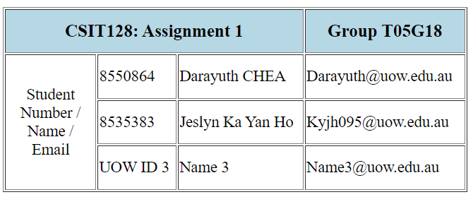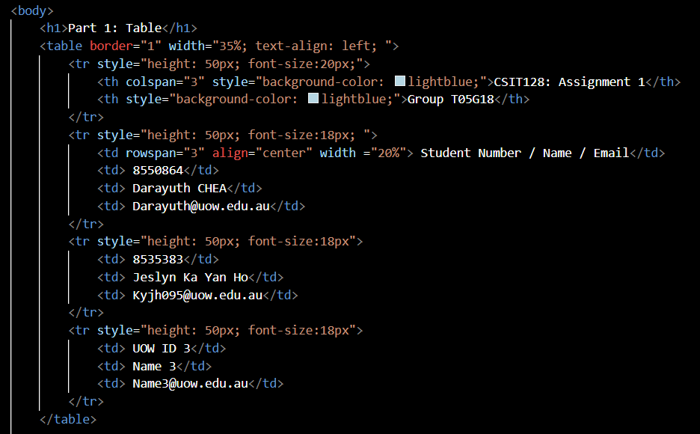

**Explanation:**

This section contains a table where information about our Student ID, Name and email will be displayed. In order to make the table more visible to read, we choose to utilize the border attributes of 1px, with a width property of 35% in the <table> element and text-align: left.

Inside this table, there’s a row for header we use the element called ‘th’, however we use the attribute 'colspan' with a value of 3 to enable the header of CSIT128: Assignment 1 to have three columns underneath it. While for the header of Group T05G18 there is only one row beneath the heading, we don’t need to utilize any additional characteristics there.

The Student Number, Name, and Email header uses a 'row span' element with a value of 3 since there are three rows there for us to enter our information.

**Part 2: Hello World program with different languages**

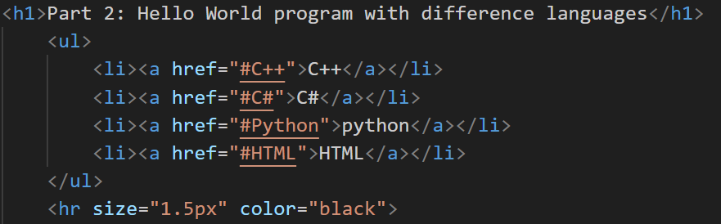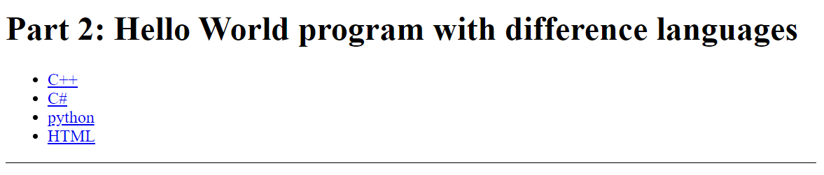

For part 2 I start with <h1> as the title/header and in this part, we will explain how to generate ‘Hello World’ with different program languages. Following with <ul> which is unordered list, we use this to create a list with all the languages that provided such as C++, C#, python and HTML. We also add on the <a href> to link those titles to each part of the website without scrolling down to search for it. We also divide the part with the horizon line with <hr> and adjust some style by increasing the size to make it look better.

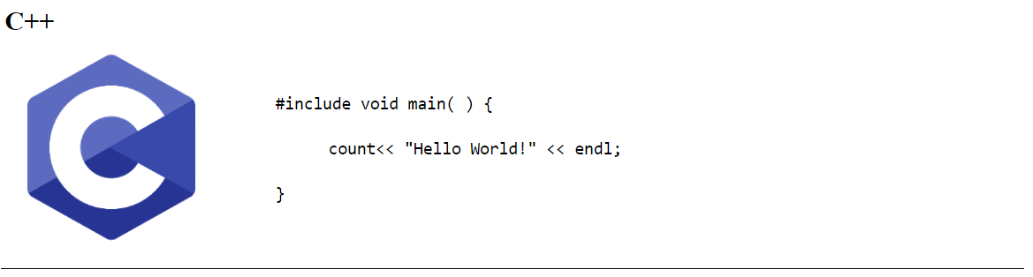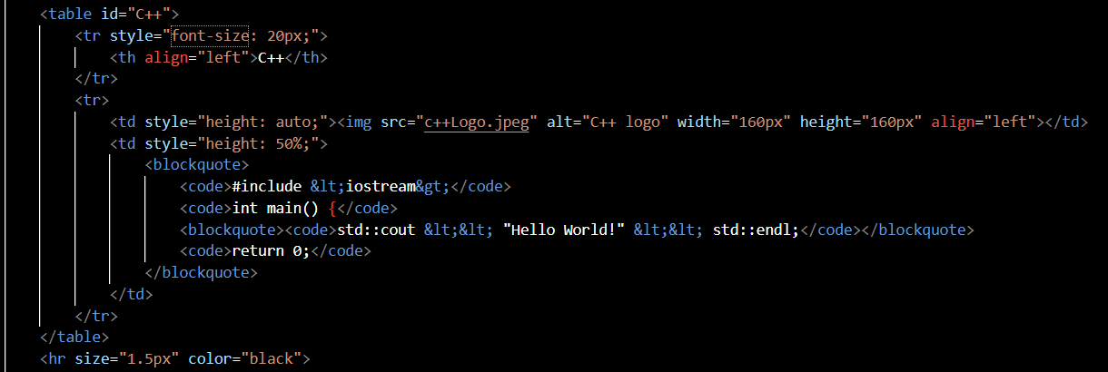

If we click on C++, it will bring you to this portion and that is how you print the Hello World with C++ program. Inside that I create it as tables, and I call it id=”C#” so that the program knows where I want to call that by clicking on the link above. Follow by insert Image inside that I call from the source src=”c++Logo.png” and adjust image size with width and height. Inside <blockquote> I want the text to pop up exactly like what I typed included indents and spacings, but for “{ ” and “ } ” the code will confuse it a syntax so I need to declare many <blockquote>. For <code> I want the text to show like coding fonts, so im using this method.

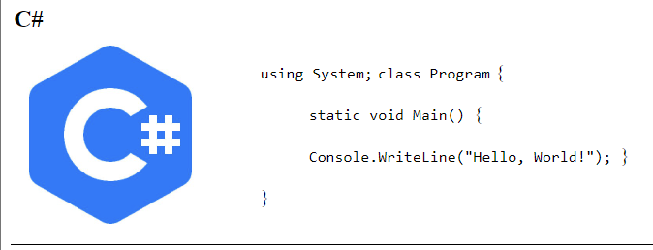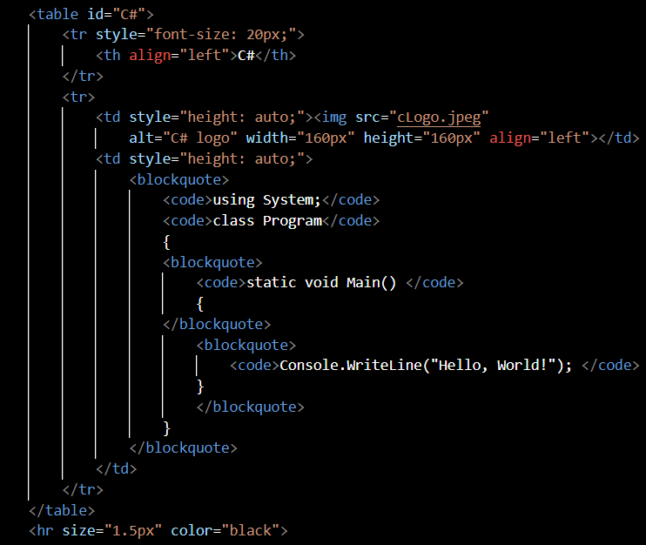

Same things, if we click on C# it will bring u to C# part and the detail on how to print Hello World with that program languge. We use <blockquote> so we can set the text as it coded without using <br>, and for the image I set it as src=”images/2.png”.

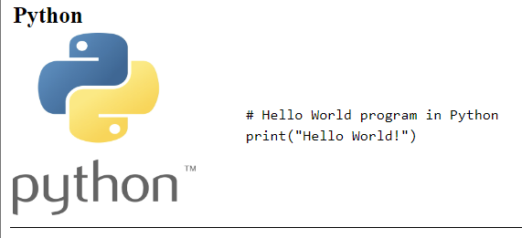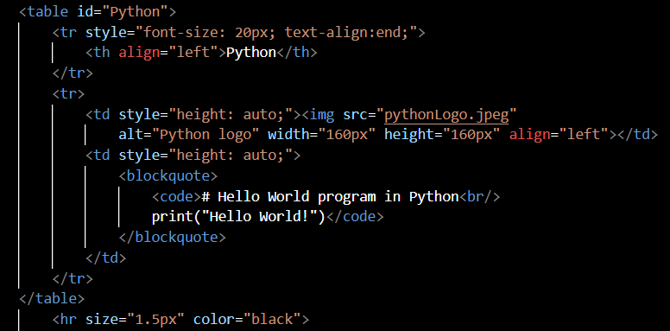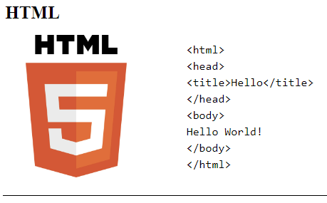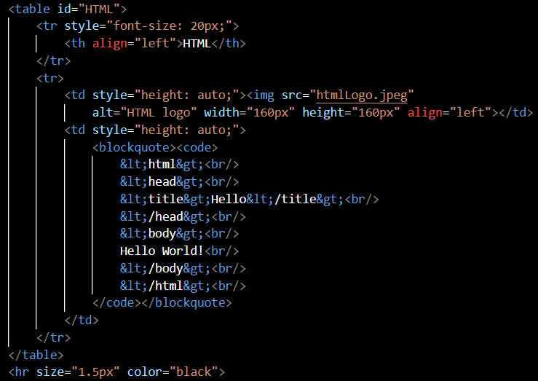

There goes same for last 2, Python & HTML. For Python it is easy and short to print out Hello World, and I call the src=”images/3.png” so it knows there to get the Python logo. For HTML, not much difference either, I name the picture as src=”images/4.png”, but for the code it require lots of “ <,>” sign so we need to use ( &lt; ) knows as less then, and ( &gt; ) is greater sign. Every part it divide by <hr> horizon line and it all in table structure.

# Part 3: University policies and services

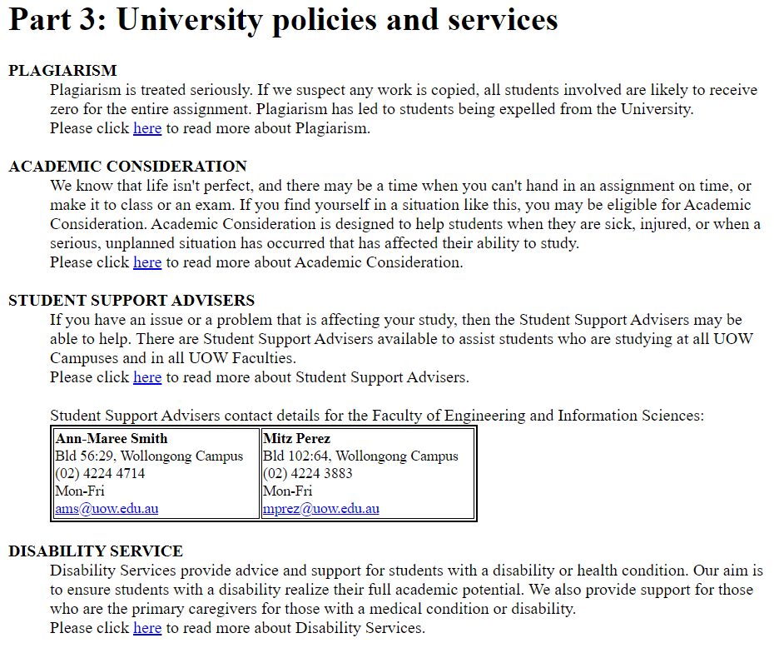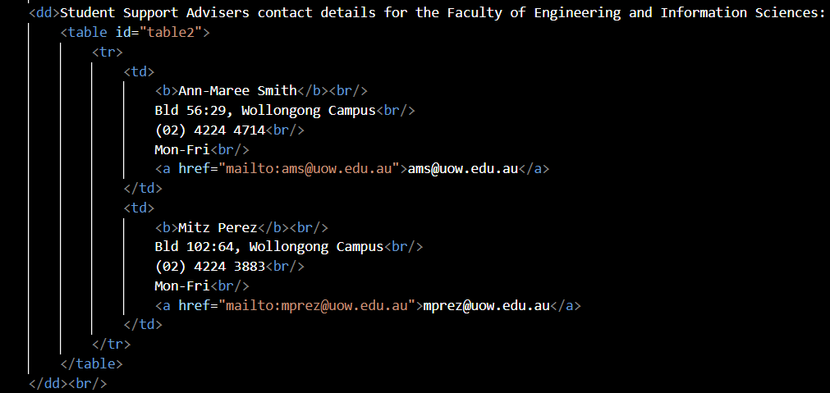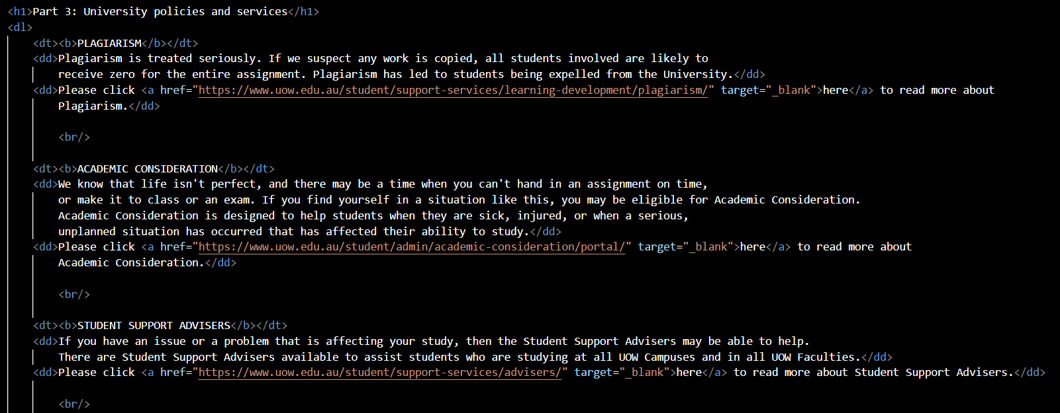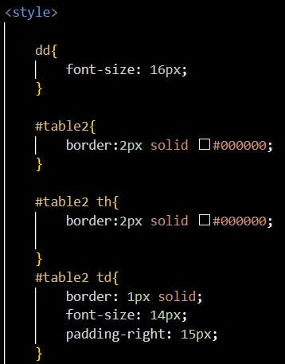

**Explanation:**

Part 3: University policy and services is covered in this part. When it comes to academic considerations, disability services, student support advisers, and plagiarism. We had use the element of <dt> and <dd> to create a description list.

There are a few links that will direct user to UOW University policy and services website. In order to do so, we use this <a href="xxxLink " target="_blank">here</a> element. The link might open a new tab in the browser thanks to the Target="_blank"> attribute.

# Part 4: Submission Form

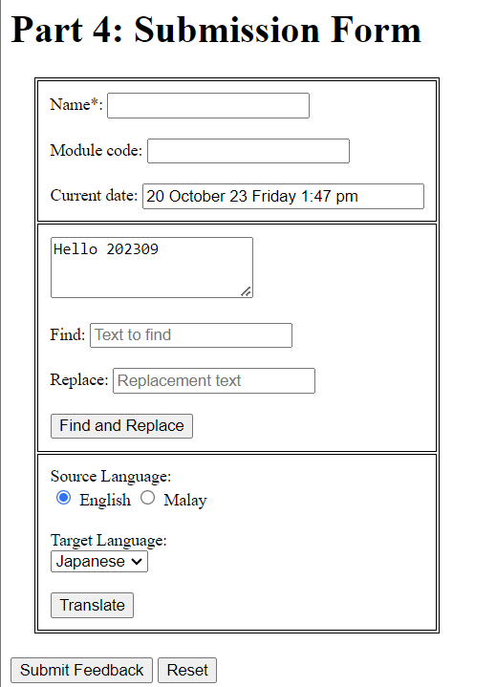

**Name, Module Code, Current date**

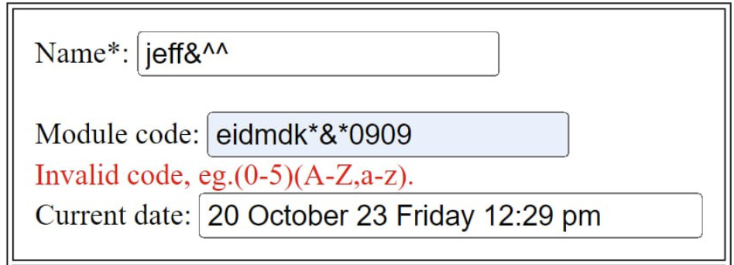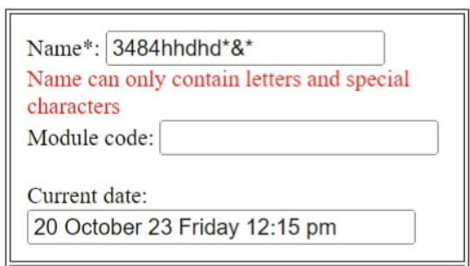

**Script**

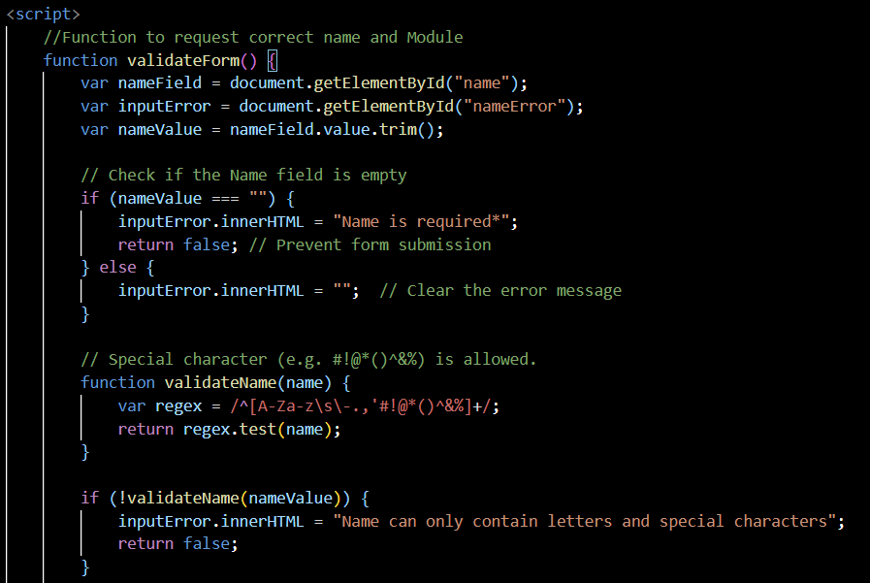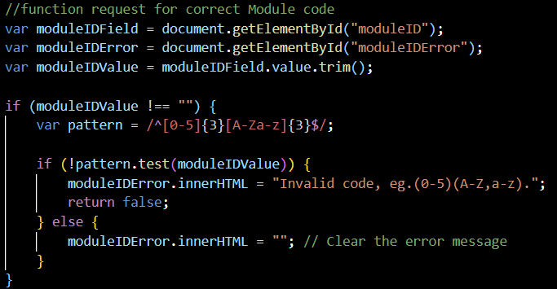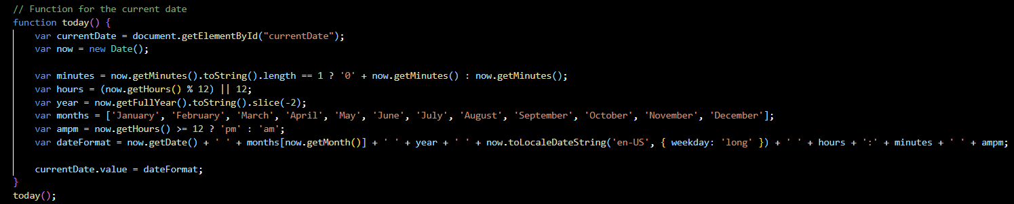

**Html**

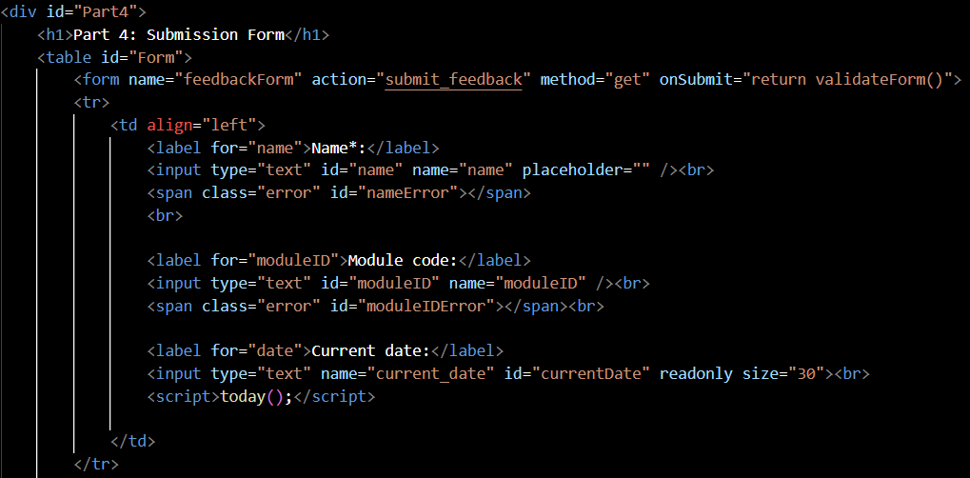

**Explanation:**

Part 4 is the submission form and it divide into 3 tables. For the first one we have name as it need to be filled correctly with regular expression pattern /^[A-Za-z\s\-.,'#!@*()^&%]+/ , if not the system will says "Name can only contain letters and special characters" ask you to input again.

Next is Module code, no difference form name but it can be blank, user can ignore it if they doesn't have , but it still require the correct pattern as /^[0-5]{3}[A-Za-z]{3}$/ so it require first 3 digits from range (0-5) and follow by any letters without special characters.

The last part of first table is Current Date, it display by defaults and it syn to real time/ your device Date and Time

**Text Area, Find and replace text, Find and Replace button**

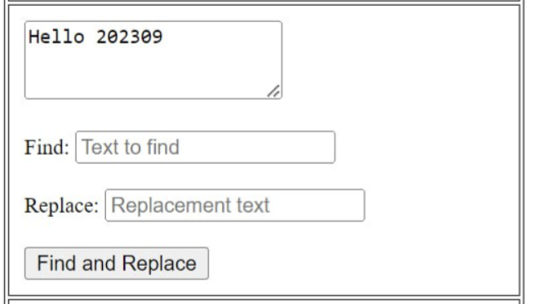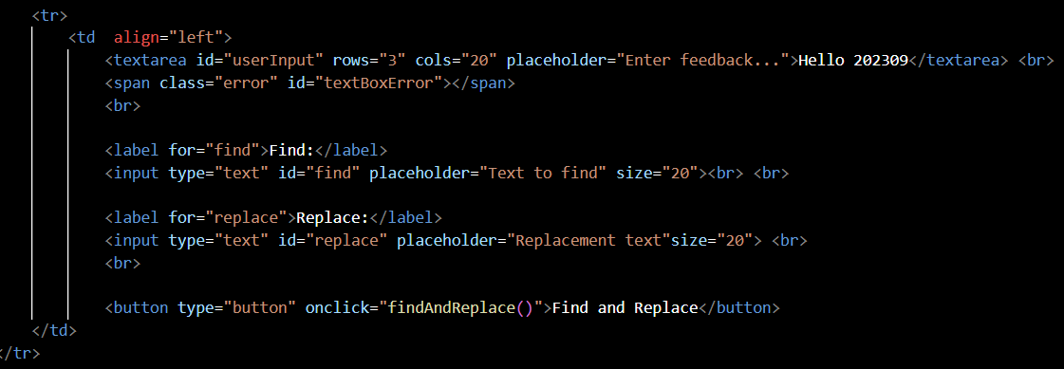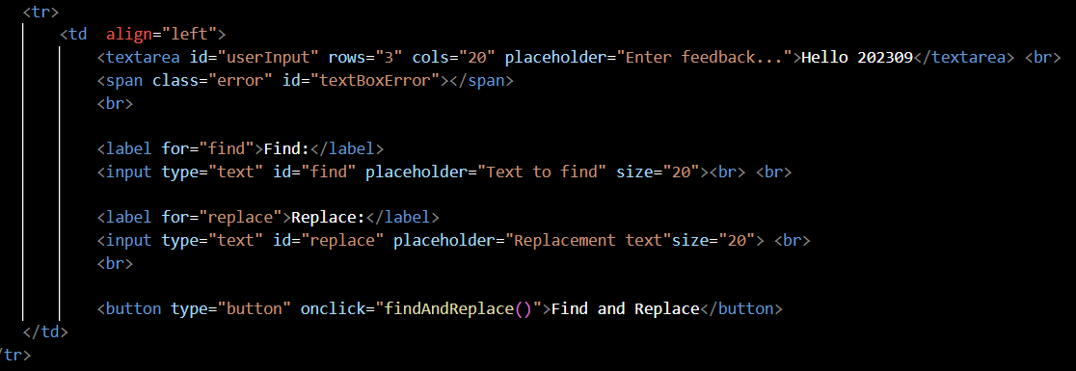

**Explanation:**

The second table starts with text area using <textarea> and we size the container with 3 rows and 20 columns <rows="3" cols="20" > and it shown 'Hello 202309' as default and it cant be empty.

For Find&Replace, it is a method that allow user to replace any words they want, as user can search the word by type it in Find text box and it will scan all the text in text box above and you can replace it with the words that u want to replace in Replace text box below. After that u just click on the ' Find and Replace ' button and it will automatically change the words for you.

**Language Translation**

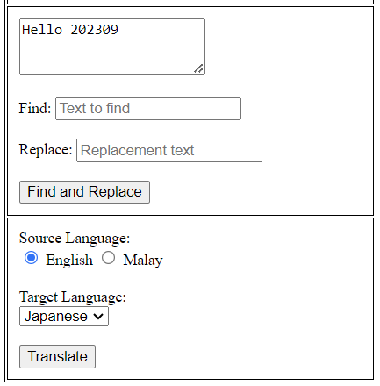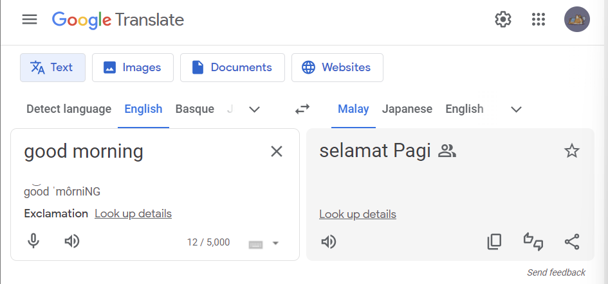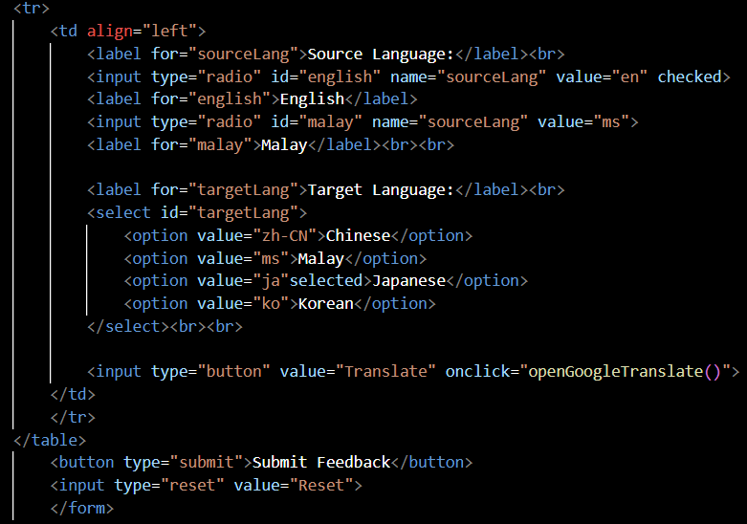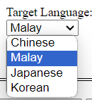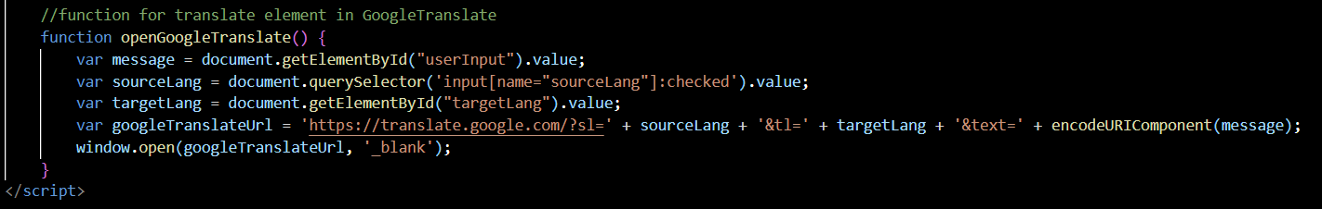

**Explanation:**

This section here allows user to Translate the sentence that they had input in the text area. For the Source Language we had use a radio button, with only English and Malay,

While for the Target language we had use a selection list of only Chinese, Malay, Japanese and Korean. Once user have input and press the translate button, it will direct the user to google translate.

<input type="radio" id="english" name="sourceLang" value="en" checked>:

This code creates an English language radio button, which you can see is checked to set it as the default language.

<option value="ja" selected>Japanese</option>:

This is an drop down option, the attribute select allow the Japanese language to be set as default.

<input type="button" value="Translate" onclick="openGoogleTranslate()">

When user click the button, the openGoogleTranslate(), will be called.

var sourceLang = document.querySelector('input[name="sourceLang"]

This line of code here use the querySelector method to find the attribute name=”sourceLang” which is from the radio button.

var targetLang = document.getElementById("targetLang").value;

This line find value with the ID of targetLang.

'sl=' + sourceLang: A query parameter for source language.

'tl=' + targetLang: A query parameter for target language.